Database System Engineering and Distributed Backend Development
Course Code: 25CS13002E
ROLL NO:2520030177
NAME: P.HARINI
BANK DATABASE – SQL VIEWS
Query 1: CREATE DATABASE
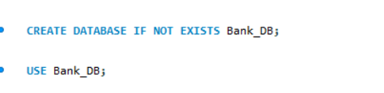
Output:
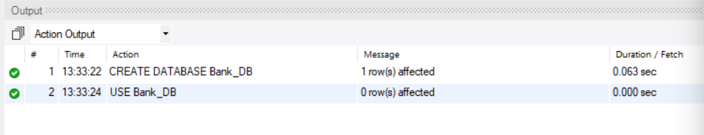

Query 2: CREATE CUSTOMER TABLE
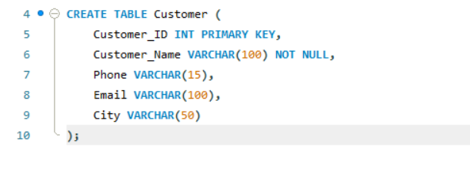
Output:

Query 3: CREATE ACCOUNT TABLE
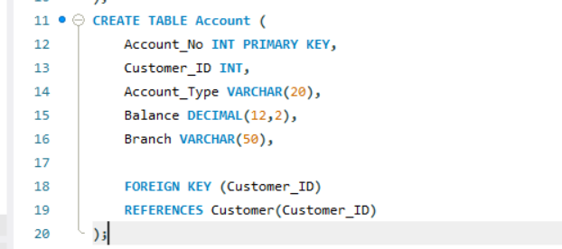
Output:

Query 4: CREATE BANK TRANSACTION TABLE
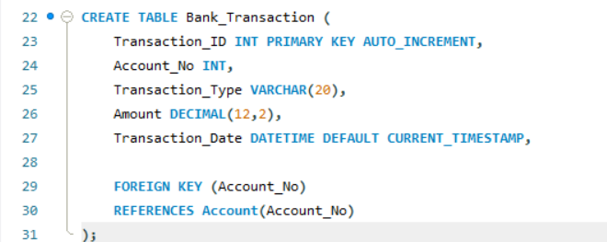
Output:

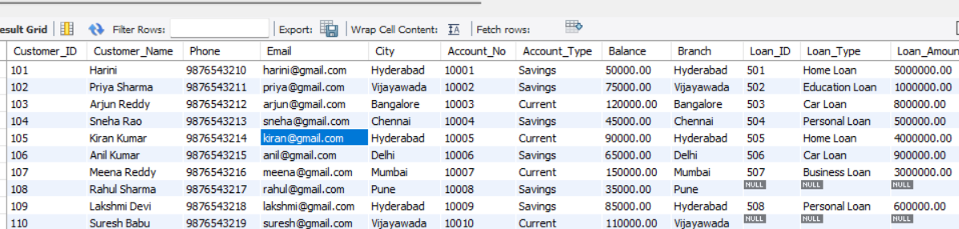

Query 5: CREATE LOAN TABLE
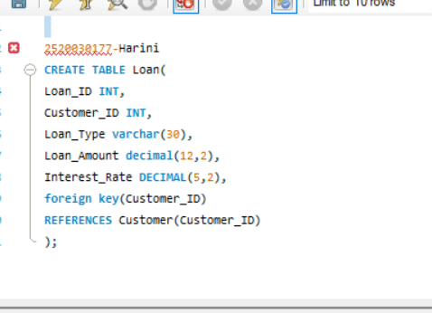
Output:

Query 6: INSERT CUSTOMER DATA
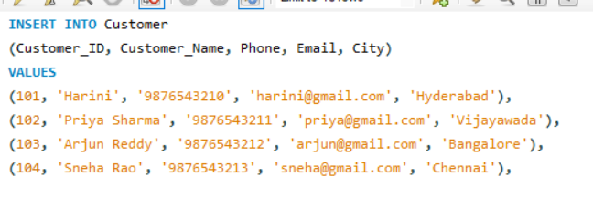
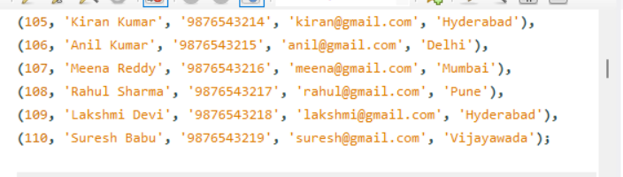
Output:

Query 7: INSERT ACCOUNT DATA
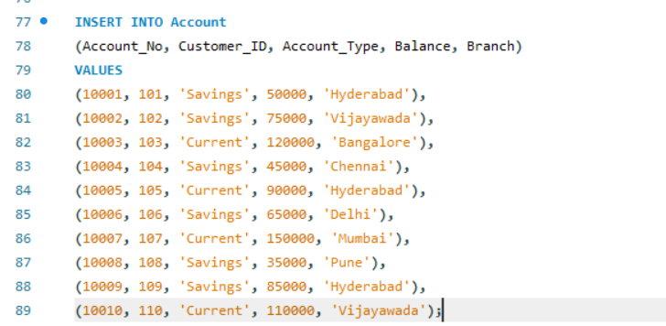
Output:
Query 8: INSERT TRANSACTION DATA
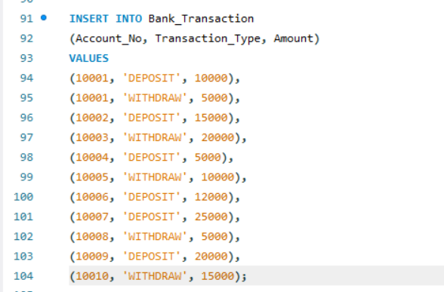
Output:

Query 9: INSERT LOAN DATA
=
Output:

Query 10: DISPLAY ORIGINAL TABLES
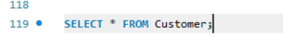
Output:

Query 11:
Output:
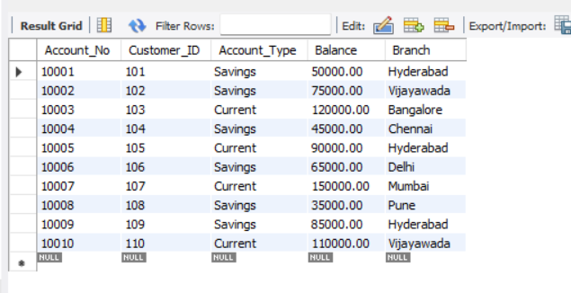
Query 12:
Output:
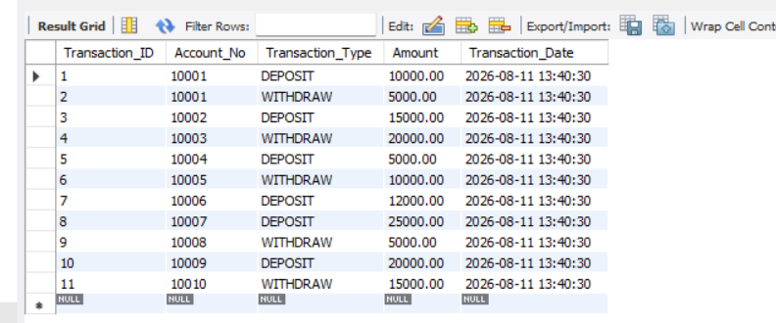
Query 13:

Output:
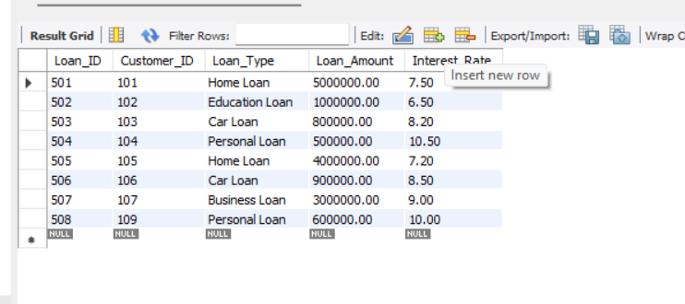

Query 14:CREATE A VIEW FOR ALL CUSTOMERS
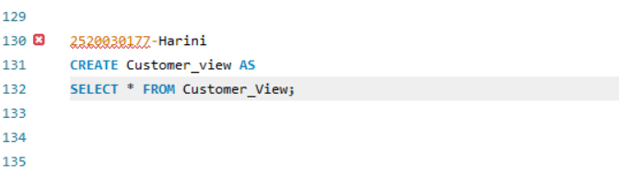
Output:
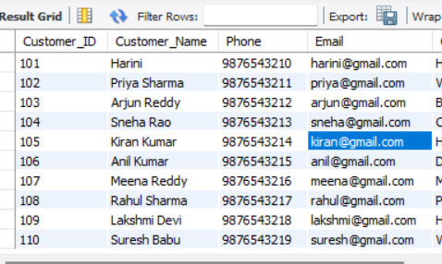
Query 15: CREATE A VIEW FOR CUSTOMER BASIC INFORMATION
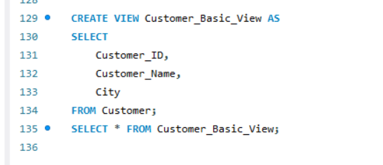
Output:


Query 16: CREATE A VIEW FOR ACCOUNT INFORMATION
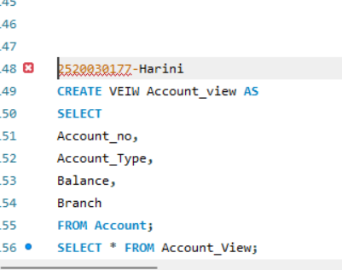
Output:


Query 17: CREATE A VIEW FOR SAVINGS ACCOUNTS
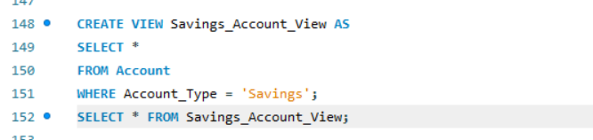
Output:
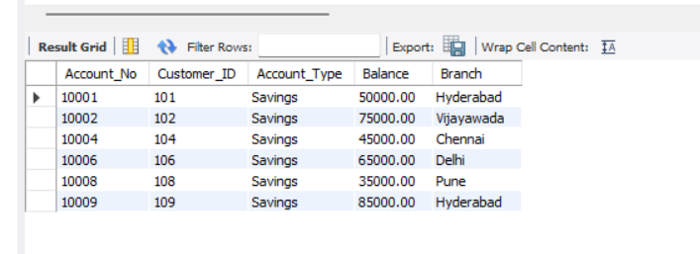

Query 18: CREATE A VIEW FOR CURRENT ACCOUNTS
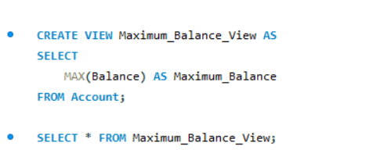
Output:
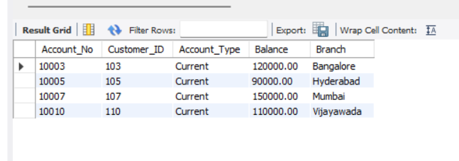

Query 19: HIGH BALANCE ACCOUNT VIEW
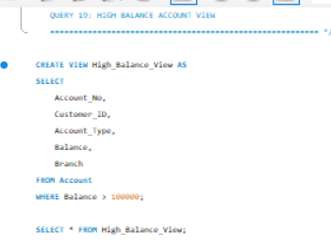
Output:
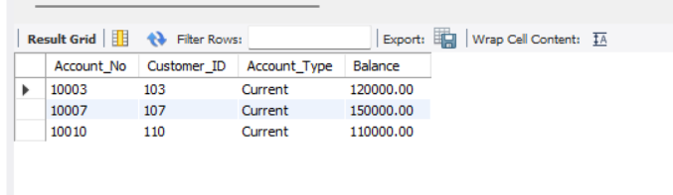

Query 20: HYDERABAD ACCOUNT VIEW
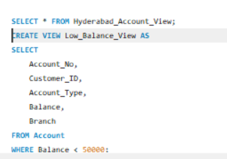
Output:
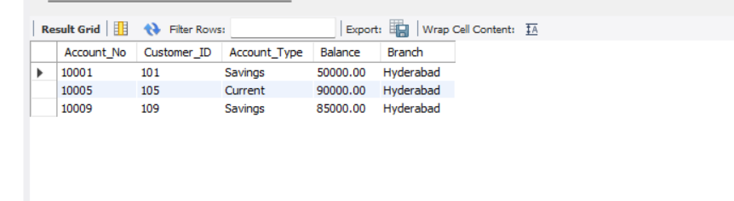
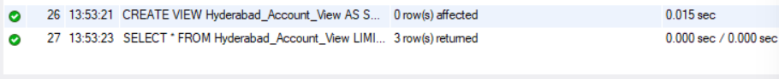

Query 21: LOW BALANCE ACCOUNT VIEW
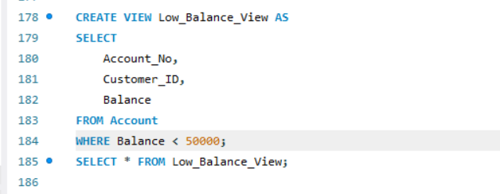
Output:
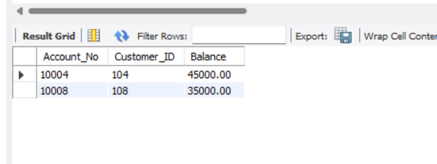

Query 22: CUSTOMER + ACCOUNT VIEW
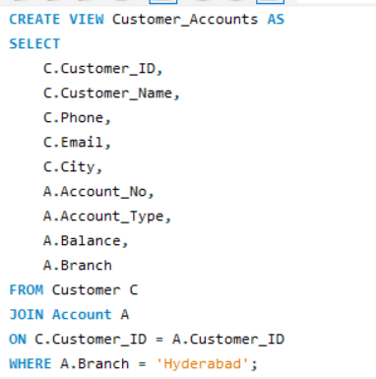
Output:

Query 23: HYDERABAD CUSTOMER ACCOUNT VIEW
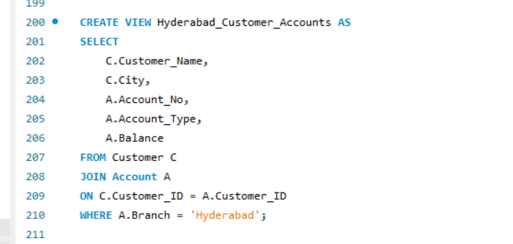
Output:

Query 24: CUSTOMER LOAN VIEW
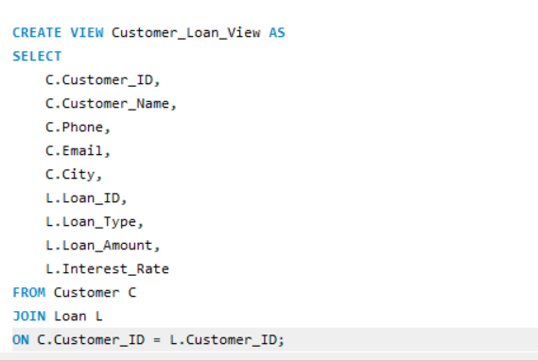
Output:

Query 25: COMPLETE CUSTOMER BANKING VIEW
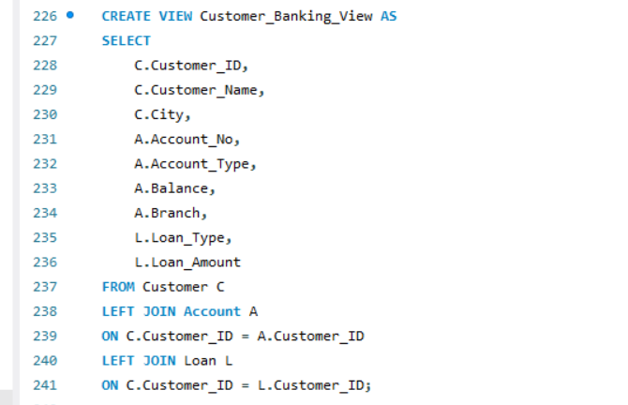
Output:
Query 26: TOTAL BANK BALANCE
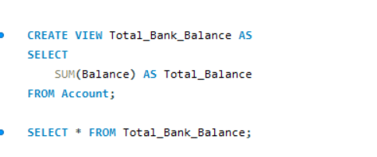
Output:
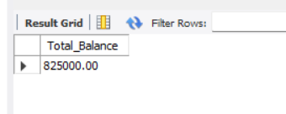

Query 27: AVERAGE ACCOUNT BALANCE
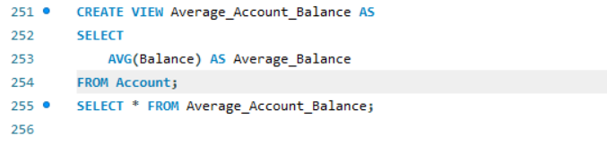
Output:
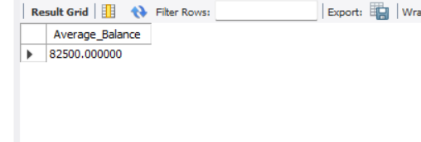
Query 28: MAXIMUM ACCOUNT BALANCE
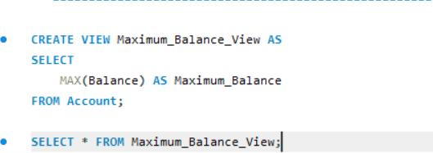
Output:

